**Project Report**

**Problem Statement:**

“To build an image recognition model which is capable of identifying the pattern on a dress image.”

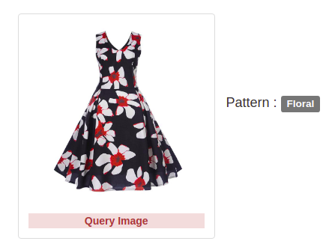

We have a dataset having a list of image URLs. Each URL has an image of a dress and a tag indicating the pattern on the fabric

**Data**

|  |  |  |  |  |  |  |  |  |  |  |  |  |
| --- | --- | --- | --- | --- | --- | --- | --- | --- | --- | --- | --- | --- |
| _unit_id | category | category:confidence | image_url |  |  |  |  |  |  |  |  |  |
| 8.52E+08 | ikat | 0.3487 | http://s3-eu-west-1.amazonaws.com/we-attributes/dress/23/5f635c0fa59f4270a6953f67dcddcda3.jpg.png | | | | | | | | | |
| 8.52E+08 | plain | 1 | http://s3-eu-west-1.amazonaws.com/we-attributes/dress/24/ca5ca27caca94f9fb0617c226477ae35.jpg.png | | | | | | | | | |
| 8.52E+08 | polka dot | 0.6709 | http://s3-eu-west-1.amazonaws.com/we-attributes/dress/27/7be73e354249484db5a8ddf4e05cc63b.jpg.png | | | | | | | | | |
| 8.52E+08 | plain | 1 | http://s3-eu-west-1.amazonaws.com/we-attributes/dress/30/7e241481162649d39048f522d0653e03.jpg.png | | | | | | | | | |
| 8.52E+08 | geometry | 0.7035 | http://s3-eu-west-1.amazonaws.com/we-attributes/dress/35/808d0bf9fe9745fca13ab461f86e0e4e.jpg.png | | | | | | | | | |
| 8.52E+08 | geometry | 0.6585 | http://s3-eu-west-1.amazonaws.com/we-attributes/dress/36/239faf3c69e44268ba411a91afd8ca98.jpg.png | | | | | | | | | |

❏ This dataset contains links to images of women's dresses.

❏ The corresponding images are categorized into 17 different pattern types.

❏ Most pattern categories have hundreds to thousands of examples.

Total link is 15634 that means total dataset images is 15634.

**Approach:**

I use Collab for this project .

My first approach first we make a program that scrap images from the given link and save in google drive. After that use CNN to train the model that can use to predict pattern of dress.

**Solutions:**

First we clean the dataset there are 70 approx dupicates dataset link , so we first clean the dataset and after that make program that fetches images from the given link and save in google drive. After that we apply CNN model to train the model. We use keras layer to make our model and apply flow from Dataframe function to for image augmentation.

**Results:**

for fitting model in our image dataset. Here we take batch size of 32. its accuracy is 70 percent on unknown dataset. i analyse that in first epoch accuracy on training dataset accuracy is 54% but on test dataset accuracy is 56% , so in each epoch error rate decreases and accuracy increases, here i use epoch 25 so as we know at iteration of epoch accuracy increase.